t

ESA EO Operations Framework (EOF)
CSC - Ground Segment Master ICD

APPROVAL
Title | ESA EO Operations Framework (EOF) - CSC - Ground Segment Master ICD
Issue Number | 1 | Revision Number | 7
Author | Coordination Desk Team | Date | 15/03/2024
Verified By | Bogdana Tsonevska | Date of Verification
Approved By | Jolyon Martin H/EOP-GCY
 | Berenice Guedel H/EOP-GCS
Authorised By | Betlem Rosich H/EOP-GC

CHANGE LOG
Copernicus Ground Segment Sentinels Data Flow Configuration | Issue Nr | Revision Number | Date
On-demand distribution deletion and other editorial updates | 1 | 3 | 7/12/2021
Editorial updates and  Update on Interfaces for 2022 Checkpoint | 1 | 4 | 28/09/2022
Update on Interfaces for new Services integration | 1 | 5 | 31/03/2023
Update on Interfaces for new Services integration  And baseline | 1 | 6 | 11/10/2023

CHANGE RECORD
Issue Number 1 | Revision Number 4
Reason for change | Date | Pages | Paragraph(s)
Editorial changes on S1, S2, S3, S5P baselines | 28/09/2022 | 31-35 | 4.1,4.2,4.3,4.4
Editorial changes on ICD references | 28/09/2022 | 26 | 3
Deletion of CSC-PODIP-PRIP interface | 28/09/2022 | 9,14 | 1.5, 2.4
Deletion of CSC-FOS-POD interface | 28/09/2022 | 9, 17, 21 | 1.5, 2.6, 2.9
Added CSC-MPC-FOS for S1 | 28/09/2022 | 22 | 3.6
Removing of GTDEV files from CSC-FOS-ADG interface | 28/09/2022 | 20,22 | 3.5, 3.6
Data Access Acronym has been changed from DD to DA | 28/09/2022 | All | All
Issue Number 1 | Revision Number 5
Change of a wrongly referred IF reference: from ESA-EOPG-EOPGC-IF-11 to ESA-EOPG-EOPGC-IF-4 for CSC-DA-E2E | 31/03/2023 | 24 | 3.8, 3.11
Added CSC-AIP-IPF IF | 31/03/2023 | 12,35 | 3.10,3.14
Added CSC-PRIP-IPF IF | 31/03/2023 | 12,18,19,20,35 | 3.4, 3.14
Added CSC-PODIP-PS IF | 31/03/2023 | 12,18,19,20,29 | 3.4, 3.9
Added CSC-FOS-E2E IF for S3 | 31/03/2023 | 12,23,24,27,28 | 3.6, 3.8
Added CSC-EXT-ADG IF for S3 | 31/03/2023 | 12,21,22 | 3.5
Added CSC-MPIP-ADG IF | 31/03/2023 | 12, 14,15,21,22 | 3.1, 3.5
Added CSC- EDIP-E2E IF | 31/03/2023 | 12,17,27,28 | 3.3, 3.8
Added CSC- CADIP-RS IF | 31/03/2023 | 12,16,34 | 3.2, 3.13
Added CSC-RS-PS IF | 31/03/2023 | 12,18,19,20,34 | 3.4, 3.13
Added CSC- EDIP-RS IF | 31/03/2023 | 12,17 | 3.3, 3.13
Added CSC-RS-MPC IF | 31/03/2023 | 12,26,34 | 3.7, 3.13
Added CSC-PRIP-MP IF | 31/03/2023 | 12, 14,15,18,19,20 | 3.1, 3.4
Added CSC-OTR-E2E IF | 31/03/2023 | 12,27,28,33 | 3.8, 3.12
Change XBIP in CADIP | 31/03/2023 | 12,16 | 3.2
Change I/F protocol MP from FTP in HTTPS | 31/03/2023 | 14,15 | 3.1
Added CSC-DLR-MP | 31/03/2023 | 12, 14,15 | 3.1
Added CSC-FOS-MPC and CSC-MPC-FOS IFs | 31/03/2023 | 12,23,24,26 | 3.6, 3.7
Change of a wrongly referred IF reference from COPE-SERCO-TN-16-0054 to ESA-EOPG-EOPGC-IF-4 for CSC-DA-USER IF | 31/03/2023 | 31,32 | 3.11
Updated S1 Baseline | 31/03/2023 | 41,42 | 5.1
Issue Number 1 | Revision Number 6
Update ICD References | 05/07/2023 | 35-37 | 4
Update of S1 Baseline | 05/07/2023 | 39 | 5.1
Update of S2 Baseline | 05/07/2023 | 40 | 5.2
Update of S3 Baseline | 05/07/2023 | 41-42 | 5.3
Update of S5p Baseline | 05/07/2023 | 43-45 | 5.4
Overall editing and typo check | 05/07/2023 | all | all
Update CSC-LTA-E2E to CSC-AIP-E2E | 05/07/2023 | 25-26  28 | 3.8,3.10
Updated CSC-EDIP-E2E | 05/07/2023 | 25-26, 17 | 3.8,3.3
Update reference MP IFs | 05/07/2023 | 14-15, 16,17 | 3.1 , 3.2 , 3.3
Alignment Acquisition IFs with DDP IFs applicable for S5p and CADIP Ifs applicable for S1&S2&S3. Documentation update | 05/07/2023 | 16, 25-26, 18,19, 20-21,17,32 | 3.2 ,3.8 ,3.4 ,3.5 ,3.3 ,3.13
Documentations update for EDRS IFs | 05/07/2023 | 17,14-15, 32 | 3.3, 3.1, 3.13
Documentation update and applicability changes in ADGS IFs | 05/07/2023 | 20-21, 18-19, 24 | 3.4,3.5, 3.7
Documentation update and applicability changes in RS IFs | 05/07/2023 | 13,18-19,33,24, 16 | 3.13,3.4, 3.14 ,3.7 ,3.2
CSC-PODIP-PS & CSC-PODIP-DA removed S5P from applicable mission and added S6 mission | 05/07/2023 | 27,18-19,29-30 | 3.9 ,3.4 ,3.11
Removal of the CSC-E2E-FOS IF | 05/07/2023 | 23,26 | 3.6,3.8
Added all section and Ifs regarding the Reprocessing Service | 05/07/2023 |  | 3.15
Updated CGS architecture with traceability service | 05/07/2023 | 11 | Figure 2
Added CSC-MPCIP-PS for S5p | 25/09/2023 | 24,32 | 3.4,3.7
Added CSC-PS-EUM (PDGS) for L0PP products S3 | 25/09/2023 | 24 | 3.4
Added CSC-PS-EUM (FOS) for IF between S3 FOS and PS | 25/09/2023 | 24,30 | 3.4,3.6
Added CSC-PS-EUM for IF between S5P PS and EUMETCAST | 25/09/2023 | 22,32 | 3.4,4
Added CSC-MPC-PS and CSC-MPC-LTA for S2 AUX_GRIXXX historical data | 25/09/2023 | 24,32,39 | 3.4,3.7,3.10
Added CSC-RPRIP-E2E | 25/09/2023 | 35,47 | 3.8,3.15
Changed version of ESA-EOPG-EOPGC-IF-13 | 04/10/2023 | 55 | 4
Changed version of ESA-EOPG-CSCOP-TN-80 | 04/10/2023 | 58 | 5.1
Deleted CSC-PRIP-IPF IF | 11/10/2023 | 27,49,54 | 3.4,3.14,4
Removed the document reference for CSC-DA-USER-1 | 11/10/2023 | 45,55 | 3.11,4
Changed CSC-DA-USER-3 in CSC-PS-USER-3 | 11/10/2023 | 45,56 | 3.11,4
Changed CSC-DA-USER-5 in CSC-PS-USER-5 | 11/10/2023 | 45,56 | 3.11,4
Removed CSC-DA USER-4 IF | 11/10/2023 | 45, 56 | 3.11,4
Changed reference document for traceability service | 11/10/2023 | 47,43,45,27,30  35,41,54 | 3.12,3.10,3.11  3.4,3.5,3.7,3.9  4
Added CSC-AUXIP-RS IF | 13/11/2023 | 29,49 | 3.5,3.13
Added CSC-EUM-POD and CSC-POD-EUM | 13/11/2023 | 40 | 3.9
Added CSC-PS-IPF IF | 13/11/2023 | 26, 50 | 3.4, 3.14
Added CSC-EXT-ADG for S3 (specific external interfaces) | 13/11/2023 | 28 | 3.5
Replaced S3 Baseline documents COPE-S3GS-EOPG-TN-14-0008 with ESA-EOPG-CSCOP-TN-0054 and ESA-EOPG-CSCOP-TN-0043 | 13/11/2023 | 61 | 5.3
Issue Number 1 | Revision Number 7
Added CSC-E2E-USER | 05/02/2024 | 48 | 3.8
Added CDSE executive dashboard link https://dashboard.dataspace.copernicus.eu/ | 05/02/2024 | 44 | 3.11
Sentinel-1 Product Specification document S1-RS-MDA-52-7441 version update to 3.14 | 05/02/2024 | 73 | 5.1
Updated S3 baseline | 05/02/2024 | 77 | 5.3
Updated S1 Baseline | 05/02/2024 | 75 | 5.1
Updated ICD references | 05/02/2024 | 64 | 4
Removed ESA-EOPG-EOPGC-TN-40 | 05/02/2024 | 32,39 | 3.5,3.7
Added “all” in MPIP-XB IF | 05/02/2024 | 3.1 | 17
Added in ICD references ESA-EOPG-EOPGC-IF-16 | 05/02/2024 | 65 | 4
Added CSC-MPCIP-MP IF | 16/02/2024 | 15,19,40 | Figure 3, 3.1,3.7
Added CSC-EUM-MP IF for CO2M | 16/02/2024 | 20 | 3.1
Added Copernicus Sentinel Expansion missions IF | 16/02/2024 | 15,71,72 | Figure 3, 3.2
Updated S5P Baseline | 04/03/2024 | 88 | 5.4
Replace “CSC Operations-ESA Framework “ with “ESA EO Operations Framework (EOF)” in the title and in reference documents | 05/03/2024 | 8,9 | 1.3.1
Update the ESA-EOPG-EOPGC-IF-4 data access with the actual CDSE version of the I/F | 13/03/2024 | all
Updated S2 Baseline | 15/03/24 | 83 | 5.2

Table of Contents

1. Introduction 9
1.1. Scope 9
1.2. Structure of the Document 9
1.3. Applicable and Reference Documents 9
1.3.1. Applicable Documents 9
1.3.2. Reference Documents 10
1.4. Acronyms 10
2. Overview 10
2.1. Context 10
3. EOF Ground segment component interfaces 18
3.1. CURRENT COPERNICUS MISSIONS 19
3.1.1. MISSION PLANNING 19
3.1.2. DATA ACQUISITION 24
3.1.3. EDRS 27
3.1.4. SYSTEMATIC PRODUCTION AND QUALITY CONTROL 29
3.1.5. AUXILIARY DATA GATHERING 36
3.1.6. FLIGHT OPERATIONS SEGMENT 41
3.1.7. MISSION PERFORMANCE CLUSTER 45
3.1.8. E2E Monitoring 49
3.1.9. PRECISE ORBIT DETERMINATION 53
3.1.10. DATA PRESERVATION 56
3.1.11. DATA ACCESS 59
3.1.12. OPERATIONS TRACEABILITY 63
3.1.13. REFERENCE SYSTEM 65
3.1.14. IPF MAINTAINERS 68
3.1.15. REPROCESSING SERVICE 69
3.2. COPERNICUS EXPANSION MISSION (CopEx) 71
4. ICD References 73
5. Sentinel Documentation baselines 81
5.1. Sentinel-1 82
5.2. Sentinel-2 85
5.3. Sentinel 3 86
5.4. Sentinel 5-P 89

- Introduction
  - Scope
The purpose of this document is to list the full set of interfaces applicable to the Copernicus Space Component (CSC) Ground Segment (GS) as part of the overall Copernicus Space Component ESA Framework. Both internal and external interfaces are covered and all interfaces are listed by GS component. As a Master ICD, the document does not seek to fully specify each interface, but provides a description of the content and list the involved components and applicable protocols.
  - Structure of the Document
This document is structured as follows:
- Section 1 (this section): Introduction, providing document structure, reference documents and definitions/acronyms
- Section 2: Provides a context and overview of the CSC Ground Segment and components
- Section 3: Lists the interfaces per component
- Section 4: Provides a full list of the lower-level ICDs applicable to CSC Ground Segment interfaces
- Section 5: Lists the operational processor software interfaces and baseline information per Sentinel
  - Applicable and Reference Documents
    - Applicable Documents
- ESA EO Operations Framework (EOF) – CSC –Specifications [ESA-EOPG-EOPGC-RS-1]
    - Reference Documents

- ESA EO Operations Framework (EOF) – CSC – Ground Segment Architecture [ESA-EOPG-EOPGC-TN-7]
- ESA EO Operations Framework (EOF) – CSC – Ground Segment Operational Configuration [ESA-EOPG-EOPGC-TN-62]
- ESA EO Operations Framework (EOF) – CSC – Glossary [ESA-EOPG-EOPGC-TN-13]
  - Acronyms
Please refer to [RD-3]

- Overview
  - Context
The following figure illustrates the highest-level context of the CSC Operations relevant to the ESA Framework with a synoptic view of the key internal and external interfaces:

Figure 1 High level context of the CSC Operations.

The Copernicus Space Segment ensures the instrument observations and their transfer to ground. It is composed by the dedicated Copernicus satellites, including the current Sentinel satellites and the future Expansion and Next Generation satellites. It encompasses as well the necessary post launch satellite maintenance activities and is complemented by the specific satellite commissioning facilities.

The Flight Operations Segment ensures the Copernicus spacecrafts operations, monitoring and control, including in particular:
  - Mission Control System operations (including mission scheduling)
  - Telemetry, telecommand and tracking operations within the S-band frequency
  - Satellite orbit maintenance, debris monitoring.

The Ground Segment ensures the overall handling of the data acquired by the instruments on board of the of the Copernicus satellites, including in particular:
- Implementing the mission observation scenario in line with the satellite, ground resources and constraints;
- Acquiring the Sentinel data, processing, archiving and making resulting User Level Data available;
- Guaranteeing that operational User Level Data meet the expected quality;
- Monitoring and reporting on the end-to-end operations performance.

The functions composing the Ground Segment architecture are implemented in the form of operational services, complying to a set of applicable input and output interfaces and to the corresponding operational performance requirements.

Data flow interfaces, for systematic data transfer between services, are based on the concept of small data cache areas, referred to as data “interface delivery points” (IP) hereafter. Each function or service generating a systematic or routine data flow to be further managed by one or more services, is making the output data available in an interface delivery point located on a cloud-based environment, which is logically considered as part of, and under the responsibility of, the data source service.

The high level architectural decomposition is provided in the figure below, including whenever necessary multiple instances of the same service to follow the principles indicated earlier. The number of instances illustrated for each service in the figure is not intended to represent a precise number of instances but the fact that multiple instances are present for the same service or function.
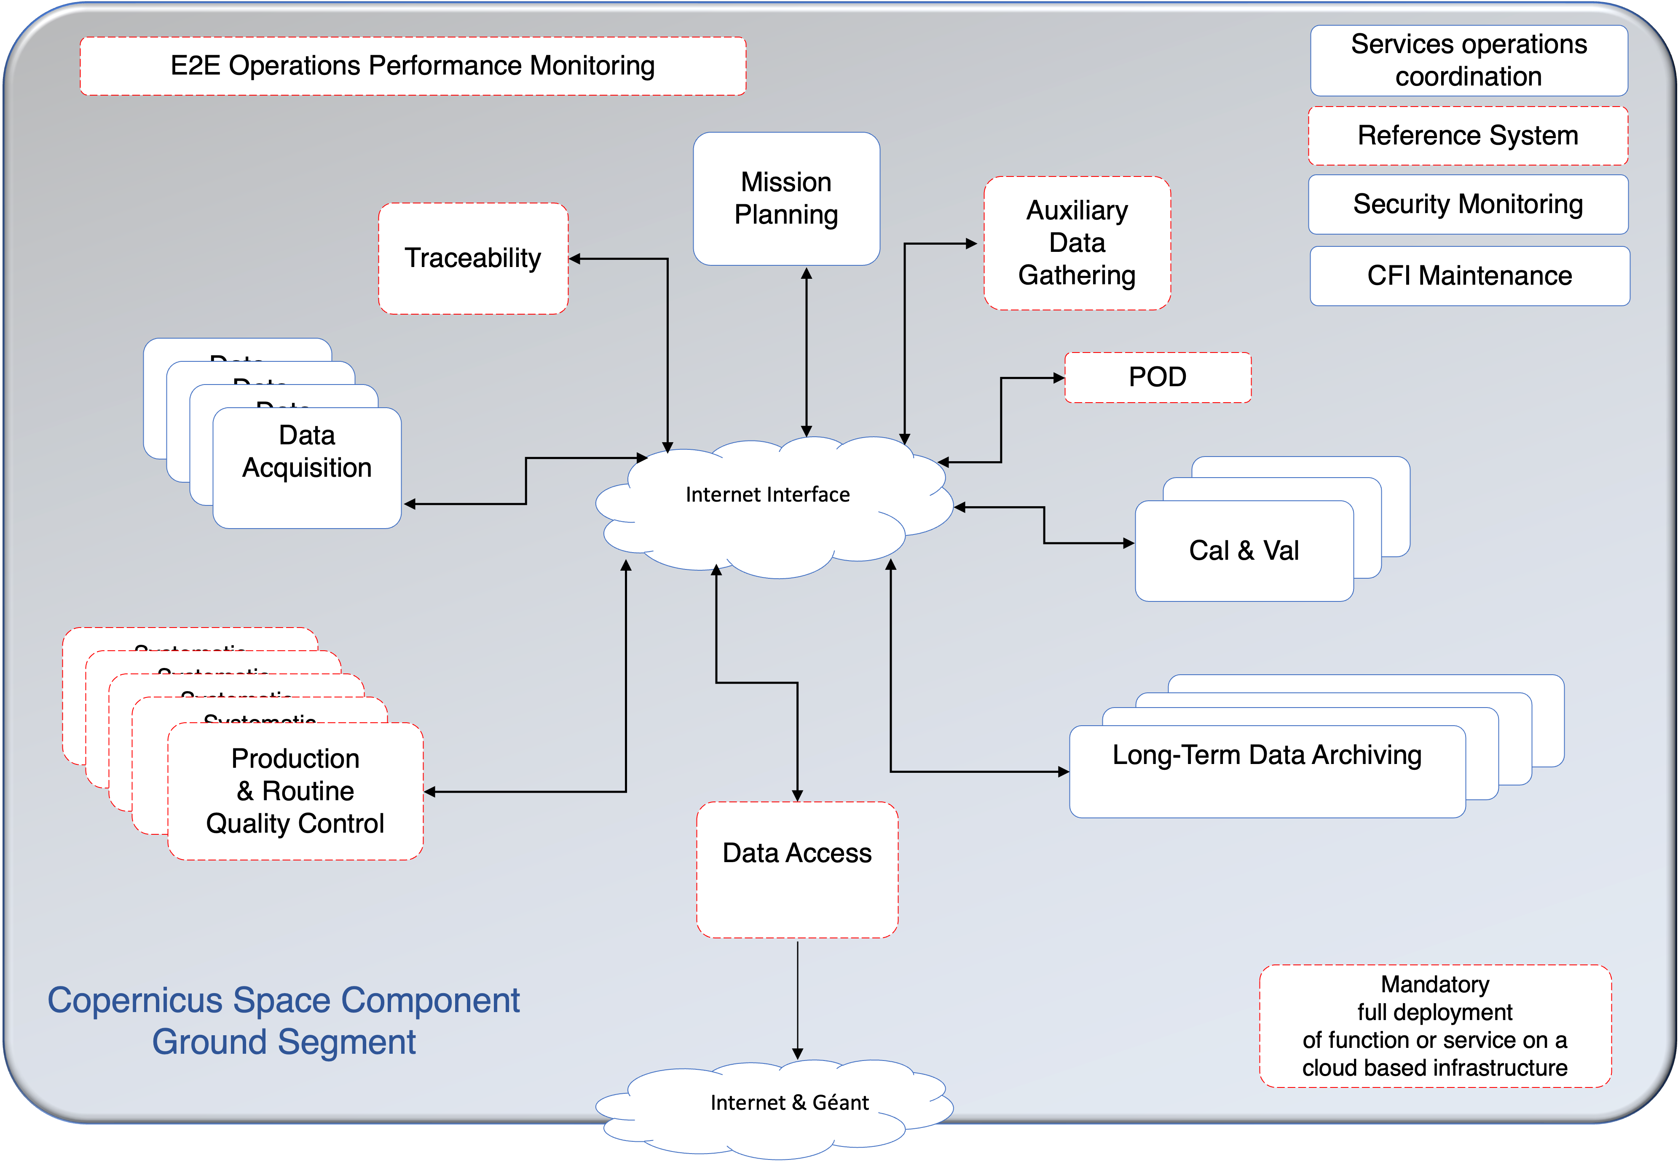
Figure 2 - High level decomposition of the ESA Copernicus Ground Segment Architecture

The components composing the Ground Segment architecture listed below and are each addressed in Section 3:
- Mission planning (MP)
- Data Acquisition
- Systematic Processing and routine quality control (PS)
- Auxiliary Data Gathering (ADG)
- Precise Orbit Determination (POD)
- Data Preservation (Long Term data Archiving (LTA))
- Data Access (including Data Distribution and On Demand Production) (DA)
- E2E Operations performance monitoring (E2E)
- Flight Operations Segment (FOS)
- Mission Performance Cluster (MPC)
- IPF Maintainer (IPF)
- Reference System (RS)
- Reprocessing Service (RPR)
- Operations Traceability(OTR)

The interfaces to and from the following elements are not fully traced in this version of the master ICD:
- Instrument data processing algorithm and operational processor maintenance (CFI Maintenance)
- Instrument and products calibration and validation
  - The operational processor software interfaces and baseline information are instead presented in section 5
  - The operational interface to provide these software to the interested elements is within the Reference System as a well-documented software configuration control element, managed by procedure within the E2E Operations Coordination.
  - The main internal interfaces of the products calibration and validation are traced in this document, external ones (e.g. for external validation data) are not further developed.
- E2E Operations Coordination
- In a similar way, the E2E Operations Coordination services will be governed by a set of procedures, at this time no systematic data flow interfaces have been identified.
- Security monitoring
- Security monitoring interfaces are generally procedural and defined by the security requirements applicable to each GS element.

The figure below shows summarises the components of the Copernicus Ground Segment and highlights all interfaces (by interface identifier) between GS components covered in this document. They are described in the next section.

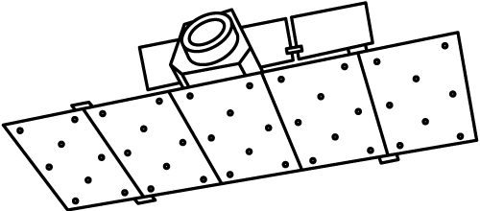
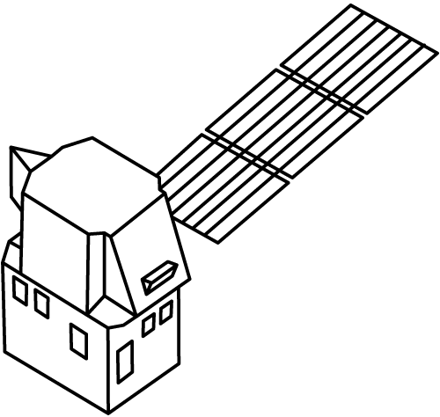
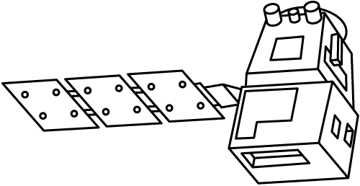
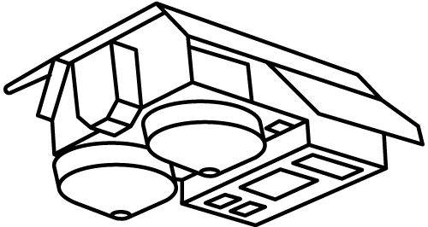
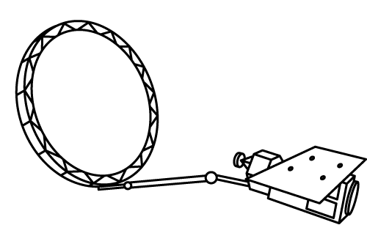

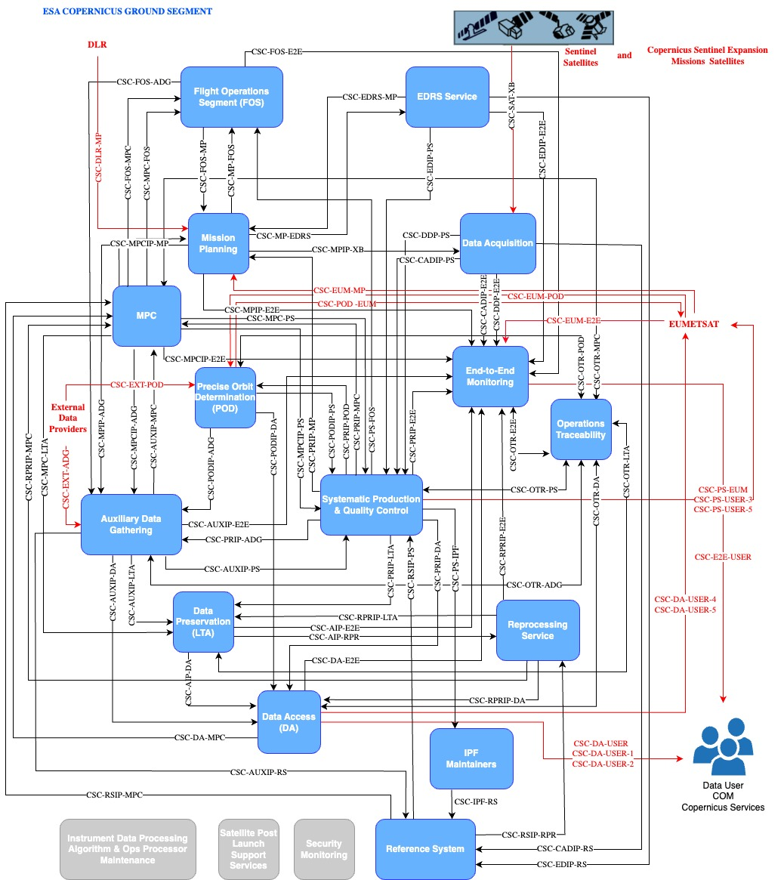
Figure 3 GS IFs Flow

- EOF Ground segment component interfaces
This section lists the interfaces for each Ground Segment component. Both internal and external interfaces are included. Each interface is described with the following properties:
- Interface ID: In the format: CSC-<’FROM’ Component>-<’TO’ Component>. For example, CSC-MP-FOS is the interface from the Mission Planning to the Flight Operations Segment.
- Interface Description: A textual description of the interface properties
- Interface Content: A list of the content that will be passed across the interface
- Int/Ext: Whether the interface is internal or external wrt the Ground Segment
- From: The source component
- To: The destination component
- Interface Protocol: The protocol(s) applicable to the data passed across the interface
- ICD References: Reference(s) to the ICD(s) fully specifying each interface
- Notes: Additional notes where necessary

  - CURRENT COPERNICUS MISSIONS

  - COPERNICUS EXPANSION MISSION (CopEx)
In the frame of the Copernicus Programme, new missions are being designed to expand the current capabilities of the Copernicus space component. New satellites are planned to be launched in 2025 and 2026. The services IF are not consolidated yet and a preliminary view of operational interfaces is given in the table below.

Copex Specific IF
EOF I/F ID | Mission | I/F Description | IF content | Int/Ext | From | To | I/F Protocol | ICD References | Notes
Acquisition
CSC-SAT-XB | CIMR | Interface between Sentinel satellites for X-Band payload and HKTM data reception | Payload data,  houskeeping &telemetry data | Ext | Satellite | Data Acquisition | Space to Ground | CIRR-ICD-TAI-SC-0002
CSC-SAT-KB | CHIME | Interface between Sentinel satellites for KA-Band payload and HKTM data reception | Payload data,  houskeeping &telemetry data | Ext | Satellite | Data Acquisition | Space to Ground | CHIM-ICD-TAS-SY-0580
CSC-SAT-XB | CRISTAL | Interface between Sentinel satellites for X-Band payload and HKTM data reception | Payload data,  houskeeping &telemetry data | Ext | Satellite | Data Acquisition | Space to Ground | CRIS-ICD-ADSF-SAT-1000887555
CSC-SAT-KB | ROSE-L | Interface between Sentinel satellites for KA-Band payload and HKTM data reception | Payload data,  houskeeping &telemetry data | Ext | Satellite | Data Acquisition | Space to Ground | ROSE-ICD-TAI-SY-0001
CSC-SAT-KB | LSTM | Interface between Sentinel satellites for X-Band payload and HKTM data reception | Payload data,  houskeeping &telemetry data | Ext | Satellite | Data Acquisition | Space to Ground | LSTM-ICD-ADSM-SAT-1001172831
Mission Planning
CSC-MP-NASA | Cristal | TBD | TBD | TBD | TBD | TBD | TBD | TBD
CSC-NASA-MP | Cristal | TBD | TBD | TBD | TBD | TBD | TBD | TBD
Data Access
CSC-DA-SS | TBD | TBD | TBD | TBD | TBD | TBD | TBD | TBD
CSC-DA-NASA | TBD | TBD | TBD | TBD | TBD | TBD | TBD | TBD
CSC-DA-EUM | TBD | TBD | TBD | TBD | TBD | TBD | TBD | TBD

- ICD References
This section lists the applicable versions of the lower-level ICDs to the CSC Ground Segment interfaces. Each ICD is described with the following properties:
- EOF IF ID: The interface identifier in the format: CSC-<’FROM’ Component>-<’TO’ Component>
- Context: The applicability of the ICD within the GS, e.g. mission, POD etc
- DOC ID: The document identifier of the ICD
- Title: The title of the ICD
- Date: The date of issue of the version indicated
- Issue/Revision: The currently applicable issue/revision of the ICD
- Notes: Additional notes where necessary

EOF IF ID | Context | DOC ID | Title | Date | Issue | Revision | Comment
CSC-SAT-XB | Sentinel-1 | S1-IF-TASI-SY-004 | Sentinel-1A Space to Ground ICD | 26/11/2013 | 2 | 7 | Space to Ground ICD unchanged in EOF transition
CSC-SAT-XB | Sentinel-2 | GS2.ICD.ASD.SY.00006 | Satellite to Ground Segment Interface Control Document | 04/03/2014 | 9 |  | Space to Ground ICD unchanged in EOF transition
CSC-SAT-XB | Sentinel-3 | S3-ID-TAF-SC-00438 | Sentinel-3 Space to Ground ICD | 06/06/2014 | 9 |  | Space to Ground ICD unchanged in EOF transition
CSC-SAT-XB | Sentinel-5P | S5P.ICD.ASU.SY.00007 | Satellite - Ground Segment Interface Control Document |  | 10 | 0 | Space to Ground ICD unchanged in EOF transition
CSC-MPIP-XB | Sentinel-1  Sentinel-2  Sentinel-3  Sentinel-5P | ESA-EOPG-EOPGM-IF-1 | X-band Ground Station Data Reception Interface Control Document | 11/11/2019 | 1 | 1
CSC-MPIP-XB | Sentinel-1  Sentinel-2  Sentinel-3  Sentinel-5P | ESA-EOPG-EOPGC-IF-16 | MISSION PLANNING INTERFACE POINT (MPIP) ICD | 06/10/2023 | 1 | 1 | The MPIP is not fully operational yet
CSC-DDP-PS  CSC-DDP-E2E | Sentinel-5P | ESA-EOPG-EOPGM-SP-1 | X-band Ground Station Data Delivery Point Interface Control Document | 07/11/2019 | 1 | 1 | The baseline for Sentinel-5P in the EOF for transfer of CADU to the production system
CSC-DDP-E2E | Sentinel-5P | ESA-EOPG-CSCOP-RS-17 | X-band Acquisition Operational Reporting Requirements | 08/01/2019 | 1 | 0
CSC-AUXIP-E2E | Sentinel-1  Sentinel-2  Sentinel-3  Sentinel-5P | ESA-EOPG-EOPGC-IF-10 | Auxiliary Data Interface Delivery Point Interface Control Document | 26/04/2023 | 1 | 5 | The generic interface for Production delivery Interface Point applies for delivery of POD products to PR, LTA, DD (and reporting via harmonised API)
CSC-AUXIP-MPC | Sentinel-1  Sentinel-2 | ESA-EOPG-EOPGC-IF-10 | Auxiliary Data Interface Delivery Point Interface Control Document | 26/04/2023 | 1 | 5 | The generic interface for Production delivery Interface Point applies for delivery of POD products to PR, LTA, DD (and reporting via harmonised API)
CS-AUXIP-LTA  CSC-AUXIP-DA  CSC-AUXIP-PS  CSC-PODIP-DA | Sentinel-1 Sentinel-2 Sentinel-3 | ESA-EOPG-EOPGC-IF-10 | Auxiliary Data Interface Delivery Point Interface Control Document | 26/04/2023 | 1 | 5 | The generic interface for Production delivery Interface Point applies for delivery of POD products to PR, LTA, DD (and reporting via harmonised API)
CSC-PODIP-ADG  CSC-PODIP-PS | Sentinel-1  Sentinel-3 | ESA-EOPG-EOPGC-IF-10 | Auxiliary Data Interface Delivery Point Interface Control Document | 26/04/2023 | 1 | 5 | The generic interface for Production delivery Interface Point applies for delivery of POD products to PR, LTA, DD (and reporting via harmonised API)
CSC-MCIP-ADG | Sentinel-1 Sentinel-2 Sentinel-3 | Sentinel Specific See Section 4 | Refer to the S-X Baselines
CSC-MPCIP-PS | S5p | Sentinel Specific See Section 4 | Refer to the S-X Baselines
CSC-PRIP-DA  CSC-PRIP-LTA  CSC-PRIP-POD  CSC-PRIP-MPC  CSC-PRIP-E2E  CSC-RPRIP-LTA  CSC-RPRIP-DA  CSC-RPRIP-MPC | Sentinel-1  Sentinel-2  Sentinel-3  Sentinel-5P | ESA-EOPG-EOPGC-IF-3 | Production Interface Delivery Point Interface Control Document | 26/04/2023 | 2 | 0 | The generic interface for Production delivery Interface Point applies for delivery from systematic production to DD, LTA, POD, FOS, E2E (reporting via harmonised API)
CSC-OTR-LTA  CSC-OTR-PS  CSC-OTR-ADG  CSC-OTR-MPC  CSC-OTR-POD  CSC-OTR-LTA  CSC-OTR-DA  CSC-OTR-DA  CSC-OTR-PS  CSC-OTR-ADG  CSC-OTR-MPC  CSC-OTR-E2E  CSC-OTR-POD | Sentinel-1  Sentinel-2  Sentinel-3  Sentinel-5P | CDAS-ICD-TSY | Copernicus Data Space Ecosystem Interface Control Document |  | 1 | 0
CSC-AIP-DA  CSC-AIP-RPR  CSC-AIP-E2E | Sentinel-1  Sentinel-2  Sentinel-3  Sentinel-5P | ESA-EOPG-EOPGC-IF-2 | Long Term Archive Interace Control Document | 06/04/2023 | 1 | 9 | The baseline for ALL Sentinels in the EOF for retrieval of products from the LTA, the interface will be available from the procurement of LTA Service for S1, S2 and S3 from Q3 2020, and S5P from TBC. The interface is applicable for retrievals by DD, ODPR, as required for S1, S2, S3, S5P Auxiliary Files
CSC-PRIP-ADG  CSC-PRIP-MP | Sentinel-1 | ESA-EOPG-EOPGC-IF-3 | Production Interface Delivery Point Interface Control Document | 26/04/2023 | 2 | 0 | The generic interface for Production delivery Interface Point applies for delivery from systematic production to DD, LTA, POD, FOS, E2E (reporting via harmonised API)
CSC-AUXIP-PS  CSC-PRIP-POD  CSC-PRIP-LTA  CSC-PRIP-MPC  CSC-PRIP-DA | Sentinel-1 | ESA-EOPG-EOPGC-SP-1 | Sentinel-1 Product Unit Definition and Metadata ICD | 11/04/2023 | 1 | 8 | In support of the generic interfaces, detailed dscription of product types and metadata mapping for S1 are provided relative to the PR, AUX, ODP, LTA and DD interaces
CSC-AUXIP-PS  CSC-PRIP-POD  CSC-PRIP-LTA  CSC-PRIP-DA | Sentinel-2 | ESA-EOPG-EOPGC-SP-2 | Sentinel-2 Product Unit Definition and Metadata ICD | 11/04/2023 | 1 | 8 | In support of the generic interfaces, detailed dscription of product types and metadata mapping for S2 are provided relative to the PR, AUX, ODP, LTA and DD interaces
CSC-AUXIP-PS  CSC-PRIP-POD  CSC-PRIP-LTA  CSC-PRIP-DA  CSC-PODIP-PS | Sentinel-3 | ESA-EOPG-EOPGC-SP-3 | Sentinel-3 Product Unit Definition and Metadata ICD | 11/04/2023 | 1 | 8 | In support of the generic interfaces, detailed dscription of product types and metadata mapping for S3 are provided relative to the PR, AUX, ODP, LTA and DD interaces
CSC-AUXIP-PS  CSC-PRIP-DA  CSC-PRIP-LTA  CSC-PRIP-MPC | Sentinel-5P | ESA-EOPG-EOPGC-SP-4 | Sentinel-5P Product Unit Definition and Metadata ICD | 11/04/2023 | 1 | 4 | In support of the generic interfaces, detailed dscription of product types and metadata mapping for S5P are provided relative to the PR, AUX, ODP, LTA and DD interaces
CSC-PODIP-DA  CSC-PODIP-LTA  CSC-PODIP-PR | Sentinel-1  Sentinel-2  Sentinel-3  Sentinel-6A | ESA-EOPG-EOPGC-SP-5 | POD Files Definition and Metadata ICD | 20/02/2023 | 1 | 5 | In support of the generic interfaces, detailed dscription of product types and metadata mapping for POD are provided relative to the PR, LTA and DD interaces
CSC-DA-USER  CSC-DA-E2E  CSC-DA-MPC  CSC-DA-USER-2 | Sentinel-1  Sentinel-2  Sentinel-3  Sentinel-5P | CDAS-ICD-TSY | Copernicus Data Space Ecosystem Interface Control Document |  | 1 | 0
CSC-FOS-MP  CSC-FOS-E2E  CSC-FOS-ADGS  CSC-FOS-MPC | Sentinel-1 | S1-IC-ESC-FS-3000 | FOS to CGS Interface Control Document | 01/12/2024 | 4 | 0 | IP address for MPC updated
CSC-FOS-MP  CSC-FOS-E2E  CSC-FOS-ADGS | Sentinel-2 | GS2-IC-ESC-FS-3000 | FOS to CGS Interface Control Document | 15/09/2022 | 1 | 7
CSC-MP-EUM | Sentinel-3 | GMES-S3GS-EOPG-IC-10-0006 | Sentinel-3 PDGS to FOS Interface Control Document | 06/05/2015 | 1 | 4
CSC-MP-FOS | Sentinel-5P | Systematic Production | Sentinel-5 Precursor PDGS PDGS-FOS ICD | 03/09/2017 | 2 | 3 | The Sentinel-5P GS to FOS ICD is currently defined in the Sentinel-5 Precursor PDGS PDGS-FOS ICD and is applicable through the S-5P acquisition service currently under contract until 12-2021
CSC-MP-EDRS | Sentinel-1  Sentinel-2 | GMES-GSEG-EOPG-IC-12-0034 | GSC Ground Segment - EDRS Ground Segment Interface Control Document | 03/04/2018 | 3 | 5
CSC-PS-USER-3 | Sentinel-5P | S5P-PDGS-DLR-ICD-3055 | PDGS-CalVal users ICD | 04/09/2018 | 1 | 6 | Inteface with CAMS for FTP delivery
CSC-PS-USER-5 | Sentinel-5P | S5P-PDGS-DLR-ICD-3067 | PDGS-to-MMDS-EUMETCast- ICD |  | 1 | 0 | Interface with EUM for FTP push for EUMETCAST
CSC-DA-USER-1 | ALL |  |  |  |  |  | Executive dashboard
CSC-IPF-RS  CSC-RSIP-MPC  CSC-RSIP-PS | Sentinel-1  Sentinel-2 Sentinel-3 | ESA-EOPG-EOPGC-TN-55 | SENTINEL DATA PROCESSOR DELIVERY ICD | 21/10/2021 | 1 | 1 | External IF from Reference System towards the processor developers for the data processor delivery
CSC-EUM-E2E | Sentinel-3 | S3-IC-ESC-FS-3000 | Interface for EUM and E2E Monitoring
CSC-EXT-ADG | Sentinel-1  Sentinel-2 Sentinel-3 | ESA-EOPG-EOPGC-IF-14 | CSC External providers and Auxiliary Data Gathering ICD | 19/05/2023 | 1 | 2 | Interface between the External Provider and ADG
CSC-EDRS-MP | Sentinel-1  Sentinel-2 | GMES-GSEG-EOPG-IC-12-0034 | GSC Ground Segment - EDRS Ground Segment Interface Control Document | 03/04/2018 | 3 | 5
CSC-MP-FOS  CSC-PS-FOS  CSC-E2E-FOS | Sentinel-1  Sentinel-2 | ESA-EOPG-EOPGC-IF-13 | ESA CSC SENTINELS GROUND SEGMENT TO FLIGHT OPERATIONS SEGMENT | 04/12/2023 | 1 | 1
CSC-MPIP-ADG  CSC-DLR-MP  CSC-EUM-MP | Sentinel-1  Sentinel-2  Sentinel-3  Sentinel-5P | ESA-EOPG-EOPGC-IF-16 | MISSION PLANNING INTERFACE POINT (MPIP) ICD | 06/10/2023 | 1 | 1
CSC-EDIP-E2E | Sentinel-1  Sentinel-2 | EDRS-ICD-ADSO-1000835095 | EDC - EDRS Ground Segment to GSC Ground Segment Interface Control Document | 30/09/2020 | 1 | 0
CSC-EDIP-PS  CSC-EDIP-RS  CSC-EDIP-E2E | Sentinel-1  Sentinel-2 | GMES-GSEG-EOPG-IC-12-0025 | Sentinels DFEP to EDRS ICD | 14/07/2017 | 1 | 5
CSC-CADIP-E2E CSC-CADIP-PS  CSC-CADIP-RS | Sentinel-1  Sentinel-2 Sentinel-3 | ESA-EOPG-EOPGC-IF-15 | CADU Interface Delivery Point Specification | 20/04/2023 | 1 | 2
CSC-PS-EUM | Sentinel-5P | S5P-PDGS-DLR-ICD-3067 | S5p products to Eumetcast | 26/01/2022 | 1 | 3
CSC-PS-EUM | Sentinel-3 | ESA-EOPG-EOPGC-IF-12 | S-3 Land PDGS to EUM ICD | 20/04/2022 | 1 | 0
CSC-MPCIP | Sentinel-1 | CLS-ENV-NT-20-0226 | Standard Operating Procedure (SOP) for SHOC in 2023 | 18/09/2023 | 1. | 6

Table 16 - ICD References

- Sentinel Documentation baselines
This section lists the operational processor software interfaces and baseline information per Sentinel. Each ICD is described with the following properties:
- EOF IF ID: The interface identifier in the format: CSC-<’FROM’ Component>-<’TO’ Component> where applicable (tracing the appropriate I/F within the new Architecture
- Reference: The document identifier
- GS Instrument Processing Baseline: The title of the document
- Version: The currently applicable document version
- Date: The date of the currently applicable version
- Comment: Additional comments if necessary

  - Sentinel-1

EOF IF ID | REFERENCE | GS Instrument Processing Baseline | VERSION | DATE | Comment
 | S1-AD-XPR-MAINT-0101 | Sentinel-1 L0 Datapack Administration Document | 3.0.0 | 02/12/2022
 | GMV-SIPF-I-IPF-S1-SUM | Docker Installation Manual | V3.0 | 25/11/2020
 | S1PD.SP.001.10.ASTR | [SD-60] S-1 Core PDGS S-1 Level-0 Product Format Specifications | 3.0 | 21/11/2022 | S1 L0 processors changes  implementation for C/D units
 | S1-RS-MDA-52-7440 | Sentinel-1 Product Definition -Level 1 and Level 2 | 2.7 | 25/03/2016
 | S1-RS-MDA-52-7441 | Sentinel-1 Product Specification -Level 1 and Level 2 | 3.14 | 10/07/2023 | Review data type of some new global attribute of L2 OCN (introduced with IPF 3.60)
 | SEN-RS-52-7454 | Sentinel-1 Instrument Processing Facility Interface Control Document | 1.12 | 17/12/2021 | Introduce Processing END task (IPF-524) which create the RPT and LIST file
 | DI-MPC-IPFIM-0269 | IPF Installation Manual (Applies from IPF v3.70) | 1.16 | 01/08/2023 | Added information about docker installation procedure  Removed shmall and shmax paragraphs, as no longer relevant for the user.  Changed the paragraphs about center name configuration to reflect the new CSC-GS architecture.
CSC-MPCIP-ADG | SAR-MPC-ECE-0547 | SAR-MPC MPCIP ICD | 1.1 | 27/10/2023 | New MPCIP ICD
 | S1-RS-MDA-52-7443 | Sentinel-1 IPF Auxiliary Product Specification | 3.11 | 11/07/2023 | Clarification on the spatial and temporal resolution of the ECMWF atmospheric model auxiliary data
 | DI-MPC-IPF-OWI MPC-0469 | Sentinel-1 Ocean Wind Fields (OWI) Algorithm Definition | 2.2 | 10/10/2022 | With IPF3.60 and latter, the coastline is extracted from OpenStreetMap
 | DI-MPC-IPFDPM MPC-0307 | Sentinel-1 Level1 Detailed Algorithm Definition | 2.5 | 17/11/2022
 | S1-MA-ACS-GS-0430 | Sentinel-1 PDGS ACQ - Software User Manual | 5.0.2 | 03/09/2020 | Update of AIOP and L0ASP software set-up to Cloud environment
CSC-PODIP-PS | GMES-GSEG-EOPG-FS-10-0075 | Sentinels POD Service File Format Specifications | 3.0 | 21/07/2023 | Include Sentinel-6 products (ROE and  RINEX)
 | S1PD.ICD.00143.ASTR_4.0 | L0 Processor Internal & External ICD: SD-05-1100 [ICD-ACQ] | 4 | 18/12/2019
 | S1-IF-ASD-PL-0007 | Sentinel-1 SAR Space Packet Protocol Data Unit | Issue 13 | 22/6/2015
 | SD-10-1100-4 S1-MA-ACS-GS-0430 | L0 Processor Software User Manual | 5.0.2 | 03/09/2020 | software user manual for Cloud environment
 | SD-10-1100-3 1-MA-ACS-GS-0432 | L0 Processor Installation manual | 5.0.2 | 03/09/2020 | software installation manual for Cloud environment
 | S1-LI-ACS-GS-0420 | L0 Processor Software Configuration File | 5.0.2 | 11/07/2020
 | S1-IF-AAE-SC-0001 | Sentinel-1 satellite GPSR Command and Housekeeping interface specifications satellite GPSR Command and Housekeeping interface specifications: Housekeeping interface specifications | Issue 15 | 2/2/2012
 | MPC-0540 DI-MPC-OTH | Sentinel-1: Using the RFI annotations | 1 | 02/11/2022
 | S1-TN-NRT-52-7450 MPC-0469 | Sentinel-1 Ocean Swell Wave Spectra (OSW) ATBD | 1.5 | 10/10/2022 | Reference OpenStreetMap as source for coastline. Review of applicable documents
 | COPE-GSEG-EOPG-TN-15-0005 MPC-0474 | Sentinel-1 Level-0 Data Decoding Package | 1.3 | 28/9/2020
 | S1-TN-NRT-53-0658 MPC-0534 | Sentinel-1 Doppler and Ocean Radial Velocity (RVL) ATBD | 1.6 | 10/10/2022 | Included reference to OpenStreetMap as source of the coastline for IPF3.60 and later.
 | ESA-EOPG-CSCOP-TN-80 | Sentinel-1 ETAD Auxiliary Product Specification | 1.18 | 22/11/2023
 | ETAD-DLR-PS-0002 | Sentinel-1 ETAD Product Definition Document | 2.4 | 06/03/2023
 | ETAD-DLR-DD-0004 | Input Output Description Document | 2.5 | 22/11/2023
 | ETAD-DLR-DD-0008 | Sentinel-1 ETAD Algorithm Technical Baseline document | 2.3 | 09/03/2023
 | ETAD-DLR-DD-0009 | ETA Processor Configuration Description Document | 1.7 | 22/11/2023
 | ETAD-DLR-PS-0014 | ETAD Product Format Specification | 1.9 | 22/11/2023
 | ETAD-DLR-PS-0022 | ETAD software Installation and User Manual | 1.4 | 22/11/2023
 | ETAD-DLR-PS-0027 | ETAD Software Compilation Manual | 1.2 | 22/11/2023
 | SD-051400_S1PD.ICD.00145.  ASTR_03_SPP_ ICD__SIGNED |  | 3 |  | Only information related to the OBS processing is relevant to the PS activities
 | SD-10-1400-3_SAR-S1PD-SUM- 02561_1.13_SPP_IMA__SIGNED |  | 1.13 |  | Only information related to the OBS processing is relevant to the PS activities
 | SD-10-1400-4_SAR-S1PD-SUM- 02562_1.10_SPP_SUM__SIGNED |  | 1.10 |  | Only information related to the OBS processing is relevant to the PS activities
 | SD-11-1400-3_SAR-S1PD-TES- 02563_4.5_SPP_SVR__SIGNED |  | 4.5 |  | Only information related to the OBS processing is relevant to the PS activities
 | SD-33-1400_SAR-S1PD-SUM- 02564_4.5_SPP_SCF_  SRelD__SIGNED |  | 4.5 |  | Only information related to the OBS processing is relevant to the PS activities
 | ARE-022815 | S1-IPF-L1-OM SENTINEL-1 ERROR MATRIX PROCESSOR INSTALLATION AND USER MANUAL | 1.1 | 23/09/2022
 | ARE-022816 | S1-IPF-L1-OM SENTINEL-1 ERROR MATRIX PROCESSOR INTERFACE CONTROL DOCUMENT | 1.1 | 09/09/2022
 | ARE-022813 | S1-IPF-L1-OM SENTINEL-1 ERROR MATRIX PROCESSOR TEST PLAN AND REPORT | 1 | 09/09/2022

Table 17 - S1 Baseline

  - Sentinel-2
EOF IF ID | REFERENCE | GS Instrument Processing Baseline | VERSION | DATE | Comment
 | S1-TN-XPR-MAINT-0106 | Sentinel-2 Level-0 Datapack Benchmarking TN | 2.1 | 16/12/20 20
 | S1-AD-XPR-MAINT-0105 | Sentinel-2 Level-0 Datapack Administration Document | 2.1 | 16/12/20 20
 | GMV-SIPF-I-IPF-S2-CIDL | List of Material for Sentinel-2 IPF | 2.0 | 25/11/202 0
 | GMV-SIPF-I-IPF-S2-SUM | Docker Installation Manual | 2.0 | 25/11/202 0
 | [CICD-IPF] S2-PDGS-TAS-DI-BPDP-ICD-IPF | Sentinel-2 Products Specification Document | 15 | 29/04/2016
 | [IPF-CCDD] S2-PDGS-BP-IPF-CCDD | Software detailed design document | 19 | 09/09/2022
 | [IPF-IDD] S2-PDGS-BP-IPF-IDD | Internal Design Document | 02 | 23/06/2023
 | [IPF-SUM] S2-PDGS-BP-IPF-CCSUM | User, Operation and Maintenance Manual Document | 26 | 15/06/2023
 | S2-PDGS-MPC-L2A-IODD | Level 2A Input Output Data Definition | 2.8.0 | 29/01/2018
 | S2-PDGS-MPC-L2A-SUM | Sen2Cor Configuration and User Manual | 2.10.0 | 13/12/2021
CSC-MPCIP-ADG | OMPC.ADW.ICD.001 | Interface Control Document of MPCIP | 1 | 15/12/2021
CSC-MP-EDRS | GMES-GSEG-EOPG-IC-12-0025 | Sentinels DFEP to EDRS ICD | 1.5 | 14/07/2017
CSC-EDRS-MP | EDRS-ICD-ADSO-1000830938 | EDC - EDRS to GSC User Data Interface Control Document | 4 | 14/09/2021
 | GMES-GSEG-EOPG-IC-11-0023 | SENTINEL-2 PDGS AND COPERNICUS POD SERVICE ICD | 2.1 | 23/09/2022 | v3.0 draft
 | GS2-IC-ESC-FS-3000 | FOS TO CGS INTERFACE CONTROL DOCUMENT | 1.7 | 15/09/2022 | v1.8 to be signed soon
 | S2-PDGS-TAS-DI-PSD | Sentinel-2 Products Specification Document | 14.9 | 30/09/2021 | Next version will be in ESA naming convention
 | GMES-GSEG-EOPG-RD-09-0028 | GSC Sentinel-2 PDGS SRD | 2.4 | 10/10/2014

Table 18 - S2 Baseline

  - Sentinel 3

EOF IF ID | REFERENCE | GS Instrument Processing Baseline | VERSION | DATE | Comment
 | GMES-S3GS-EOPG-TN-09-0009 | Sentinel 3 PDGS File Naming Convention | 1.4 | 24/06/2016
 | GMES-GSEG-EOPG-TN-09-0016 | GMES Generic PDGS-IPF Interface Specifications | 1.1 | 25/02/2011
 | ESA-EOPG-CSCOP-TN-0054 | Sentinel-3 Level-0 and Level-1 Product Units configuration | 1 | 26/09/2017 | replacement of COPE-S3GS-EOPG-TN-14-0008
 | ESA-EOPG-CSCOP-TN-0043 | Sentinel-3 Land PDGS Product Units configuration | 1.2 | 08/01/2020 | replacement of COPE-S3GS-EOPG-TN-14-0008
 | S1-AD-XPR-MAINT-0103 | S3L0Datapack-Admin Doc | 1.0 | 15-10-202
 | S3IPF.ICD.001 | S3-IPF Interface Control Document - common | 1.5 | 16/03/2018
 | S3IPF.ICD.002 | S3-IPF Interface Control Document – Level 0 | 1.6 | 16/03/2018
 | S3IPF.ICD.003.1 | S3-IPF Interface Control Document – OLCI Level 1 | 1.6 | 10/05/2021
 | S3IPF.ICD.003.2 | S3-IPF Interface Control Document – OLCI Level 2 Land | 1.4 | 16/03/2018
 | S3IPF.ICD.004.1 | S3-IPF Interface Control Document – SLSTR Level 1 | 1.11 | 18/01/2024
 | S3IPF.ICD.004.2 | S3-IPF Interface Control Document – SLSTR Level 2 Land | 1.1 | 02/12/2021
 | S3MPC.ACR.AOD.005 - 01 | SLSTR L2 NRT Interface Control Document | 1 | 29/09/2017
 | S3IPF.ICD.005 | S3-IPF Interface Control Document - SYNERGY | 1.5 | 07/06/2018
 | S3IPF.ICD.007 | S3-IPF Interface Control Document – MWR | 1.5 | 13/09/2022
 | S3IPF.ICD.008.1 | S3-IPF Interface Control Document –SRAL Level 1 | 4.2 | 13/09/2022
 | S3IPF.ICD.008.2 | S3-IPF Interface Control Document –SRAL Level 2 Land | 4.2 | 12/10/2022
 | S3MPC.ACR.FRP.005 | Interface Control Document - SLSTR Level 2 Fire Radiative Power Products | 1.1 | 30/09/2019
 | S3MPC.ACR.AOD.005 - 02 | Interface Control Document - SYNERGY Level 2 Global Aerosol Products | 1.2 | 30/09/2019
 | S3IPF.ICD.009 | PUG Interface Control Document | 1 | 29/08/2016
 | S3IPF.SUM.001 | S-3-IPF User Manuals – Level 0 | 2.3 | 29/08/2016
 | S3IPF.SUM.002 | S-3-IPF User Manuals – OLCI Level 1 | 2.6 | 29/08/2016
 | S3IPF.SUM.003 | S-3-IPF User Manuals – SLSTR Level 1 | 2.5 | 29/08/2016
 | S3IPF.SUM.005 | S-3-IPF User Manuals – MWR Level 1 | 2.4 | 29/08/2016
 | S3IPF.SUM.006 | S-3-IPF User Manuals – SRAL Level 1 | 2.7 | 29/08/2016
 | S3IPF.SUM.007 | S-3-IPF User Manuals – OLCI Level 2 | 1.1 | 29/08/2016
 | S3IPF.SUM.008 | S-3-IPF User Manuals – SLSTR Level 2 | 1.1 | 29/08/2016
 | S3IPF.SUM.010 | S-3-IPF User Manuals – SYNERGY | 1.1 | 29/08/2016
 | S3IPF.SUM.011 | S-3-IPF User Manuals – SRAL Level 2 | 1.6 | 29/08/2016
 | S3IPF.SUM.012 | S-3-IPF User Manuals – SYNERGY – VGT-S | 1.1 | 29/08/2016
 | S3IPF.PDS.001 | Product Data Format Specification – Level 0 | 1.9 | 10/02/2023
 | S3IPF.PDS.002 | Product Data Format Specification – Product Structures | 1.7 | 10/09/2017
 | S3IPF.PDS.003.1 | Product Data Format Specification – SRAL and MWR Level 1 Common LAN-MAR | 3 | 25/02/2022
 | S3IPF.PDS.003.2 | Product Data Format Specification – SRAL/MWR Level 2 Land | 3.2 | 12/10/2022
 | S3IPF.PDS.003.4 | Product Data Format Specification - SRAL Level 1 Land | 1 | 25/02/2022
 | S3IPF.PDS.004.1 | Product Data Format Specification – OLCI Level 1 | 2.6 | 30/09/2022
 | S3IPF.PDS.004.2 | Product Data Format Specification – OLCI Level 2 Land | 2.4 | 19/03/2021
 | S3IPF.PDS.005.1 | Product Data Format Specification – SLSTR Level 1 | 2.11 | 18/01/2024
 | S3IPF.PDS.005.2 | Product Data Format Specification – SLSTR Level 2 Land | 2.9 | 20/08/2020
 | S3IPF.PDS.006 | Product Data Format Specification – SYNERGY | 1.15 | 08/12/2022
 | S3MPC.ACR.AOD.003-02 | Product Data Format Specification -SYN L2 NTC | 1.4 | 08/12/22
 | S3IPF.PDS.007.1 | Auxiliary Data Format Specification – OLCI Level 1 | 2.14 | 30/09/2022
 | S3IPF.PDS.007.2 | Auxiliary Data Format Specification – OLCI Level 2 | 2.14 | 18/01/24
 | S3IPF.PDS.007.3 | Auxiliary Data Format Specification – SLSTR Level 1 | 2.14 | 18/01/24
 | S3IPF.PDS.007.4 | Auxiliary Data Format Specification – SLSTR Level 2 | 2.14 | 12/12/21
 | S3IPF.PDS.007.5 | Auxiliary Data Format Specification – SYNERGY | 2.14 | 08/12/22
 | S3IPF.PDS.007.6 | Auxiliary Data Format Specification – MWR and SRAL Level 1 | 3.1 | 21/04/22
 | S3IPF.PDS.007.7 | Auxiliary Data Format Specification – MWR-SRAL Level 2 | 3.3 | 12/10/22
 | S3IPF.PDS.008 | Metadata Specification | 3.1 | 26/04/2018
 | S3MPC.ACR.AOD.004 - 02 | Auxiliary Data Format Specification – SYN L2 NTC | 1.4 | 08/12/22
 | GMES-S3GS-EOPG-IC-10-0006/EUM-LEO-SEN3-  ICD-10-0006 | Sentinel-3 PDGS to FOS ICD | 1.4 | 06/05/15
CSC-EUM-MP | S12MP_OPMAEV-GMV-ICD-002 | MPIP INTERFACE CONTROL DOCUMENT FOR S-3 AND S-5P | 1.1 | 31/03/2023
 | OMPC.ADW.ICD.001 | Interface Control Document of MPCIP | 1 | 15/12/2021 | OPT MPCIP ICD

Table 19 - S3 Baseline

  - Sentinel 5-P
EOF IF ID | REFERENCE | GS Interface Document | VERSION | DATE | Comment
CSC-EXT-ADG | S5P-PDGS-DLR-ICD-3012 | Suomi-NPP Auxiliary Data Provider ICD | 1.7 | 26/09/2023
 | S5P-PDGS-DLR-ICD-3019 | ECMWF Auxiliary Data Provider Interface Control Document | 1.6 | 21/08/2023
 | S5P-PDGS-DLR-ICD-3025 | IERS Auxiliary Data Provider Interface Control Document | 1.3 | 14/06/2023
 | S5P-PDGS-DLR-ICD-3026 | TM5 Auxiliary Data Provider Interface Control Document | 1.6 | 01/06/2023
 | S5P-PDGS-DLR-ICD-3027 | NISE Auxiliary Data Provider Interface Control Document | 1.4 | 14/06/2023
CSC-PS-USER-3 | S5P-PDGS-DLR-ICD-3055 | ODA ICD | 1.7 | 17/02/2021 | Inteface with CAMS (Copernicus Atmosphere Monitoring Service) for FTP delivery
CSC-PS-USER-5 | S5P-PDGS-DLR-ICD-3067 | PDGS-to-MMDS-EUMETCast- ICD | 1.3 | 26/01/2022 | Interface with EUM for FTP push for EUMETCAST
CSC-MPCIP-PS | S5P-KNMI-ICAL-0007-IC | ICD for the IF between the ICAL processors and PDGS | 1 | 10/01/2015
 | S5P-KNMI-L2CO-0004-SD | Static input for Level 2 processors | 4.0.0 | 21/03/2016
CSC-PRIP-MPC | S5P-PDGS-DLR-ICD-3047 | Sentinel-5 Precursor PDGS-IDAF Interface Control Document | 2.4 draft | 21/12/2018 | 2.5 In review
 | S5P-L2-DLR-ICD-3003 | UPAS Processor: External ICD | 1.0.1 | 30/11/2017
 | S5P-L2-DLR-PUM-400A | Level 2 Product User Manual O3 Total Column | 02.04.00 | 11/07/2022
 | S5P-L2-DLR-PUM-400C | Level 2 Product User Manual O3 Tropospheric Column | 02.03.00 | 04/06/2021
 | S5P-L2-DLR-PUM-400E | Level 2 Product User Manual Sulphur Dioxide SO2 | 02.05.00 | 09/06/2023
 | S5P-L2-DLR-PUM-400F | Level 2 Product User Manual Formaldehyde HCHO | 02.04.00 | 11/07/2023
 | S5P-L2-DLR-PUM-400I | Level 2 Product User Manual Cloud Properties | 02.06.01 | 10/11/23
 | S5P-PDGS-DLR-ISP-3011 | L0 Product Format Specification | 1.4 | 14/04/16
 | S5P-L2-DLR-IODD-3002 | Sentinel-5 Precursor Level 2 UPAS Processor – Input/Output Definition Document | 3.7.5 | 10/11/2023
 | S5P-KNMI-L01B-0014 | Metadata specification for the TROPOMI L1b products | 7.0.0 | 31/03/2023
 | S5P-KNMI-L2-0020-MA | L2 PUM Ozone profles | 2.6.0 | 26/09/2023
 | S5P-KNMI-L2-0021-MA | Level 2 Product User Manual Nitrogendioxide | 4.2.0 | 26/09/2023
 | S5P-KNMI-L2-0022-MA | Level 2 Product User Manual Aerosol Layer Height | 2.6.0 | 26/09/2023
 | S5P-KNMI-L2-0026-MA | Level 2 Product User Manual UV Aerosol Index | 2.6.0 | 26/09/2023
 | S5P-KNMI-OPS-0124-RP | KNMI-FOS File Specification Document | 9.0.0 | 29/03/2018
 | S5P-KNMI-L01B-0012-SD | Input/Output Data Specification for the TROPOMI L01b Data Processor | 11.00.0 | 31/03/2022
 | S5P-KNMI-L2-0009-SD | Sentinel-5 Precursor/TROPOMI KNMI and SRON Level 2 Input Output Data Definition | 18.0.0 | 01/09/2023
 | S5P-KNMI-L01B-0028-SD | Calibration key data specification for the TROPOMI L01b data processor | 8.0.0 | 31/03/2022
 | S5P-KNMI-ICAL-0011-SD | Input/output data specification for the TROPOMI in-flight calibration | 9.0.0 | 30/04/22
 | S5P-NPPC-RAL-IODD-0001 | Sentinel-5 precursor/TROPOMI Level 2 Product User Manual NPP Cloud | 2.0.0 | 11/11/22
 | SRON-S5P-LEV2-MA-001 | Level 2 Product User Manual Methane | 2.6.0 | 29/11/2023
 | SRON-S5P-LEV2-MA-002 | Level 2 Product User Manual Carbonmonoxide | 2.6.0 | 29/11/2023
 | MPC-KNMI-CC-0014-MA | PyCAMA Software User Manual | 5.8.0 | 26/05/2023
 | S5P-KNMI-ICAL-0014-MA | Software user manual for the TROPOMI in-?ight calibration processors | 11.0.0 | 30/04/22
 | S5P-KNMI-L01B-0021-MA | Input/ output data specification for the TROPOMI L01b data processor. | 13.0.0 | 31/03/2022
 | S5P-KNMI-L2-0017-MA | NL TROPOMI L2 data processors: Software User Manua | 10.0.0 | 30/04/2018
 | S5P-L2-DLR-SUM-3005 | Sentinel-5 Precursor L2 UPAS Processor – Software User Manual | 2.6.1 | 10/11/2023
 | S5P-NPPC-RAL-SUM-0001 | S5P/TROPOMI NPP-Cloud Processor Software User Manual | 2.0.0 | 02/11/2022
 | S5P-KNMI-L2-0027-IC | NL TROPOMI L2 data processors: Interface Control Document | 11.0.0 | 27/01/2020
 | S5P-KNMI-OPS-0117 | S5-P TROPOMI KNMI to FOS Interface Control Document | 13.0.0 | 08/01/2024
 | S5P-NPPC-RAL-ICD-0001 | S5P-NPP Cloud Processor Interface Control Document | 2.0.0 | 02/11/2022
 | S5P-BIRA-L2-400E-ATBD | Sulphur Dioxide ATBD | 2.5.0 | 09/06/23
 | S5P-BIRA-L2-400F-ATBD | Formaldehyde ATBD | 2.4.1 | 22/06/22
 | S5P-DLR-L2-ATBD-400I | CLOUD ATBD | 2.6.1 | 10/11/23
 | S5P-KNMI-L01B-0009-SD | L1B ATBD | 10.0.0 | 31/03/22
 | S5P-KNMI-L2-0004-RP | Ozone Profile ATBD | 1.0.0 | 22/10/21
 | S5P-KNMI-L2-0005-RP | Nitrogen dioxide ATBD | 2.4.0 | 11/07/22
 | S5P-KNMI-L2-0006-RP | Aerosol Height ATBD | 2.4.0 | 08/04/22
 | S5P-KNMI-L2-0008-RP | Aerosol Index ATBD | 2.1.0 | 22/07/22
 | S5P-KNMI-L2-0035-MA | Auxiliary Products PUM | 1.0.0 | 04/02/21
 | S5P-L2-DLR-ATBD-400A | Ozone Total Column ATBD | 2.4 | 11/07/22
 | S5P-L2-IUP-ATBD-400C | Ozone Tropospheric Column ATBD | 2.3 | 04/06/21
 | S5P-MPC-BIRA-PRF-HCHO | Formaldehyde PRF | 2.7 | 29/11/23
 | S5P-MPC-BIRA-PRF-O3-OFFL | Ozone Total Column OFFL PRF | 2.8 | 29/11/23
 | S5P-MPC-BIRA-PRF-SO2 | Sulphur Dioxide PRF | 2.8 | 29/11/23
 | S5P-MPC-DLR-PRF-CLOUD | CLOUD PRF | 2.8 | 29/11/23
 | S5P-MPC-DLR-PRF-O3 | Ozone Total Column NRTI PRF | 2.6 | 29/11/23
 | S5P-MPC-DLR-PRF-O3-TCL | Ozone Tropospheric Column PRF | 2.7 | 29/11/23
 | S5P-MPC-KNMI-PRF-AER-AI | Aerosol Index PRF | 2.6 | 29/11/23
 | S5P-MPC-KNMI-PRF-AER-LH | Aerosol Height PRF | 2.5 | 29/11/23
 | S5P-MPC-KNMI-PRF-NO2 | Nitrogen dioxide PRF | 2.5 | 29/11/23
 | S5P-MPC-KNMI-PRF-O3_PR | Ozone Profile PRF | 2.4 | 29/11/23
 | S5P-MPC-RAL-PRF-NPP | NPP Bands PRF | 1.6 | 29/11/23
 | S5P-MPC-SRON-PRF-CH4 | Methane PRF | 2.5 | 29/11/23
 | S5P-MPC-SRON-PRF-CO | Carbon Monoxide PRF | 2.6 | 29/11/23
 | S5P-NPPC-RAL-ATBD-0001 | NPP Bands ATBD | 1.0.0 | 12/02/16
 | S5P-RAL-L2-PUM-001 | NPP Bands PUM | 1.0.1 | 08/06/18
 | SRON-S5P-LEV2-RP-001 | Methane ATBD | 2.4.0 | 30/05/22
 | SRON-S5P-LEV2-RP-002 | Carbon Monoxide ATBD | 2.4.0 | 12/07/22
CSC-DLR-MP | S12MP_OPMAEV-GMV-ICD-002 | MPIP INTERFACE CONTROL DOCUMENT FOR S-3 AND S-5P | 1.3 | 14/02/2024

Table 20 - S5P Baseline

